Jal Rekha

High Level Design (HLD)

21-JAN-2026



Madhya Pradesh State Electronics Development Cooperation State IT Centre, 47-A, Arera Hills, Bhopal
https://mpsedc.mp.gov.in/

High Level Design (HLD)
Jal Rekha Project – Nirmal Module (Water Quality Monitoring)

Organization: Madhya Pradesh State Electronics Development Corporation (MPSEDC)
Client: MP Jal Nigam Maryadit
Prepared By: Rupa Malviya
Document Type: High Level Design Document
Document Control
Date | Version | Project Name | Description | Prepared By | Reviewed By | Approved By
21-09-2025 | v1.0 | Jal Rekha – Nirmal Module | High Level Design Document | Rupa Malviya | Tapan Khandelwal | Dr. Sandeep Goyal / Rakesh Dubey

- Overview
Maintaining high water quality standards is a critical challenge, especially in rural areas where water sources are vulnerable to contamination. The Nirmal module within Jal Rekha is dedicated to systematic water quality monitoring and management. Field engineers collect water samples from various components of the supply system and submit them to laboratories for testing.
Field Engineers (FE) are allowed to collect water samples only from components that have been assigned to them by the General Manager (GM) in the Dhara module. Once components are assigned in Dhara, they are automatically available in Nirmal for sampling, eliminating the need for any manual reassignment. This ensures a smooth workflow where FEs can access and record water samples strictly for their designated components, maintaining data consistency and integrity across modules.

By digitizing the water quality monitoring process, Nirmal ensures adherence to safety regulations, supports proactive health measures, and enhances the reliability of rural water supply systems.
Safe drinking water is a critical public service requirement. Continuous monitoring of water quality across schemes, treatment plants, storage points, and beneficiary endpoints is essential to ensure public health and regulatory compliance. The system improves transparency, traceability, and timely corrective action through automated workflows and alerts.
The solution aligns with state digital governance objectives and supports data-driven decision-making for water supply management.

2. System Architecture
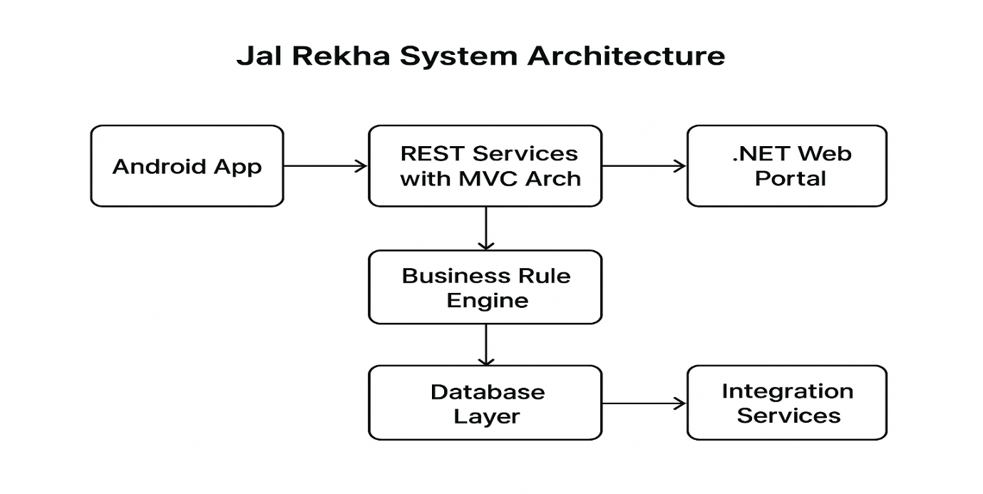
2.1 Architecture Style

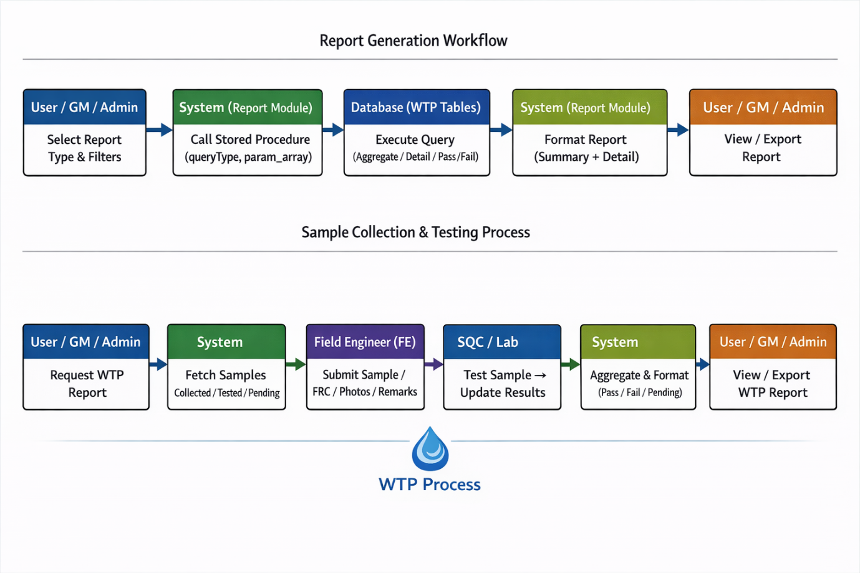

WTP inlet (Raw Water)

- The Field Engineer (FE) must collect the water sample from the WTP location, as the application is geofenced.
- The system will generate a unique sample ID, which the FE must write on the container (bottle) used for collecting the water sample that will be sent to the lab.
- The FE needs to take a photo of the sample and add relevant remarks.
- Finally, submit the survey by clicking the “Submit” button.

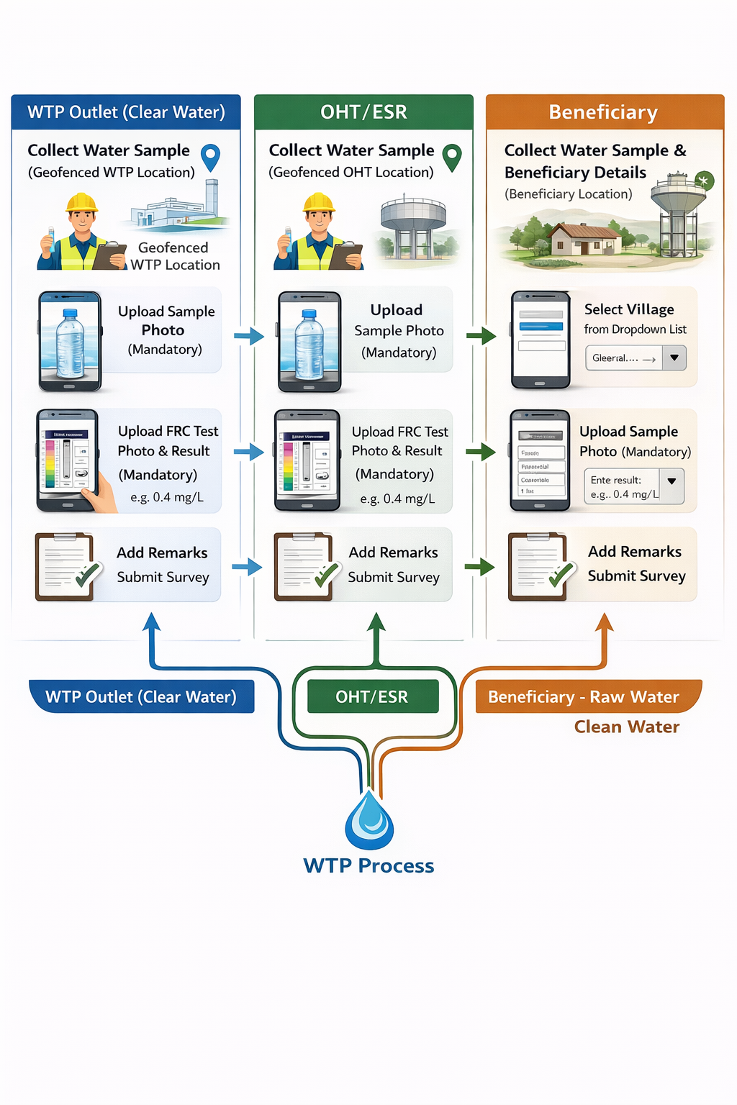

WTP Outlet (Clear Water)
- The Field Engineer (FE) must collect the water sample from the WTP location, as the application is geofenced.
- The FE needs to upload a photo of the collected water sample.
- The FE must also upload a photo of the FRC (Free Residual Chlorine) test and enter its result.
- Add relevant remarks and submit the survey.

OHT/ESR
- The Field Engineer (FE) must collect the water sample from the OHT location, as the application is geofenced.
- The FE needs to upload a photo of the collected water sample.
- The FE must also upload a photo of the FRC (Free Residual Chlorine) test and enter its result.
- Add relevant remarks and submit the survey.
- If the Field Engineer (FE) needs to collect a water sample from a beneficiary, they should click on the “Manage Beneficiary” button.
- A new page will open with three options: Pending, History, and a “+” icon at the bottom right of the page.
- Pending – If a sample is collected in a no-network area, it will be saved on the device and shown under the Pending option.

- History – All samples collected previously will be available here for the FE to review.

- To collect a new sample from a beneficiary's house, the FE should click on the “+” icon.

Beneficiary

- Field Engineer (FE) to collect and submit water quality details from a beneficiary’s location. Need to take below details:

- Village (mandatory): Select the village from the dropdown list where the beneficiary resides.

- Sample Photo (mandatory): Upload a clear photo of the collected water sample.

- Beneficiary Name (mandatory): Enter the full name of the beneficiary.

- Beneficiary Mobile Number (mandatory): Enter the beneficiary’s valid mobile number.

- Beneficiary Samagra Id (mandatory): Enter the Samagra ID of the beneficiary.

- FRC Test Photo (mandatory): Upload a photo of the FRC (Free Residual Chlorine) test.

- FRC Test Result (mandatory): Enter the FRC test result in mg/L.

- Remark: Add any relevant remarks or observations (optional).

- Once all the required fields are filled and photos uploaded, click the “Submit” button to complete the sampling process.

Web Application

For WTP/OHT/Raw-Water/ Beneficiary
- On contractor login : with valid credentials, the contractor shall navigate to the Nirmal section in the side menu and click on Water Quality List View/ WaterQualityTestReport / BeneficiaryWaterTestReport/ OHTWaterTestReport/ WTPWaterTestReport/
RawWaterTestReport
- Search Samples: The contractor shall select the required date range using Start Date and End Date, then click the Search button.
- View Sample List: A list of all water samples submitted from the field will be displayed.
- Select & Test: The contractor shall select any one sample by clicking the edit (pencil) icon in the Action column to start filling in the test reports against each predefined parameter.
- Sample Selection: When the contractor selects any sample, the “Date of Sample Received in Lab” is a mandatory field, and the date when the sample was received in the lab must be entered.
- Form Open: A form will open below with a total of 17 predefined parameters.
- Enter Test Results: The contractor must enter the test result against each parameter.
- Pass/Fail Status: The system will automatically determine whether the test has passed or failed based on the predefined limits.
- Summary: At the end of the form, it will display how many tests have passed and how many have failed.
- Upload & Remarks: The contractor can upload a document and write remarks if needed.
- Save: Finally, the contractor must save the form.

3. Logical Architecture of Nirmal
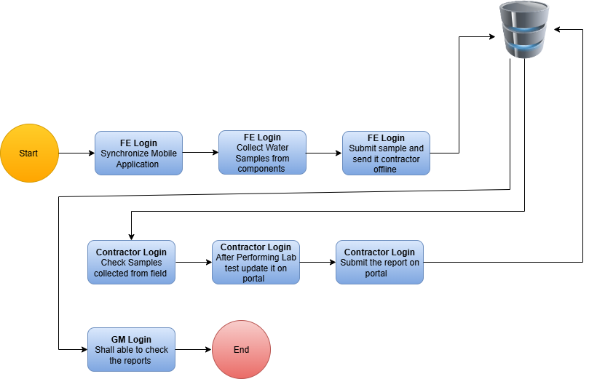
Fig: logical architecture

4. Project Components
- Frontend: ASP.NET (Web Dashboard, GIS Visualization)
- Mobile Application: Android (Core Java/Kotlin)
  - Offline Sync using SQLite / Local Storage
- Backend: RESTful WCF Services (.NET)
- Database: PostgreSQL with PostGIS (Spatial Data)
- Web Server: IIS
- Authentication: JWT Tokens
- Authorization: Role-Based Access Control (RBAC)

Web Portal (.NET-Based Front End)
- The Jal Rekha Web Portal is developed on the .NET framework, designed for department officials, administrators, and higher authorities.
- It enables planning, monitoring, approvals, task assignments, and progress tracking of water supply schemes.
- The web portal interacts seamlessly with the same RESTful services used by the mobile application, ensuring real-time synchronization of data across platforms.
- Authorized users can manage user roles, approve RFIs, generate reports, and access GIS-based dashboards through the portal.

Android-Based Mobile Front End
- The Jal Rekha Mobile Application is developed on Android to enable field-level data collection, asset mapping, inspection reporting, RFI submissions, and progress monitoring.
- The mobile application communicates with the RESTful services built using the MVC (Model-View-Controller) architecture.
- Field engineers, contractors, and other on-site users primarily interact with Jal Rekha through the mobile app.
- Future front-end applications, such as an iOS app, can also be integrated within the same architecture, but user onboarding and authentication will primarily be managed via the Android application.

REST Services with MVC Architecture
- Jal Rekha follows a decoupled RESTful architecture, allowing mobile apps, the web portal, and other integrated systems to interact independently.
- The MVC structure ensures modular development and simplifies testing, maintenance, and future scalability.
- Both the Android app and the .NET web portal communicate with these REST services after successful authentication.
- Token-based authorization is implemented at the application level to secure data exchange and user operations.

Business Rule Engine (BRE)
- The Business Rule Engine governs all workflows, validations, and approval processes within Jal Rekha.
- All rules, roles, and privileges are defined at the database level, ensuring centralized control over system operations.
- User permissions are dynamically assigned based on their roles, enabling controlled access to modules like asset mapping, inspections, approvals, reporting, and dashboards.

Database Layer
- The database layer securely manages all datasets required across the Jal Rekha platform, including user profiles, asset data, inspection details, RFI status, and scheme information.
- Data is stored using Object Relational Mapping (ORM) techniques for seamless integration between applications and the database.
- The database is synchronized between the primary server and integrated application services to ensure real-time data availability.
- Role-based access controls and privileges are also maintained at the database level to secure user operations.

Integration Services
- Jal Rekha supports integration with third-party services for better user experience and operational efficiency.
- Email services are integrated for user registration, password resets, profile updates, and notification alerts.
- Planned future integrations include:
  - SMS gateways for status updates and reminders
  - GIS-based services for advanced mapping and visualization
  - Analytics tools for insights, reporting, and performance monitoring
  - Samagra integration to Enter the Samagra ID & mobile no for beneficiary.

5. Functional Flow – Nirmal Module
5.1 Water Sample Collection Flow (Field Level)
Actors: Field Engineer (FE), Mobile Application, Backend Services
- Field Engineer (FE) logs into the Jal Rekha Mobile Application using secure credentials.
- Assigned schemes, water sources, and components (WTP, OHT/ESR, Beneficiary) are fetched from the Dhara module.
- FE selects the sampling location from the assigned list.
- The application validates geo-fencing to ensure the FE is physically present at the sampling location.
- The system generates a unique Sample ID for traceability.
- FE collects the water sample and performs the FRC test (where applicable).
- Mandatory data captured:
  - Sample photograph
  - FRC test photograph
  - FRC value (mg/L)
  - Geo-coordinates and timestamp
  - Remarks (optional)
- If network is unavailable, data is stored locally on the device.
- Once connectivity is available, data is synchronized with the backend system.
- Sample is submitted successfully for laboratory testing.

5.2 Laboratory Testing & Evaluation Flow
Actors: Contractor/Lab User, Web Portal, Quality Evaluation Engine
- Contractor logs into the Jal Rekha Web Portal.
- Submitted samples are displayed in the Water Quality List View.
- Contractor selects a sample and enters the mandatory Date of Sample Received in Lab.
- The system displays 17 predefined BIS water quality parameters.
- Contractor enters test results for each parameter.
- System automatically evaluates results against BIS drinking water standards.
- Sample status is marked as:
  - PASS – All parameters within limits
  - FAIL – One or more parameters exceed limits
- Contractor uploads supporting documents (if required) and submits the test report.

5.3 Rectification (Fail–Fix) Flow
Actors: PIU, Contractor, Field Engineer, GM/Admin
- Failed samples automatically trigger alerts to PIU, Contractor, and GM/Admin.
- Corrective actions are initiated at the field or system level.
- Field Engineer collects a re-sample following the standard sampling process.
- Re-sample is tested again in the laboratory.
- GM/Admin reviews the original and rectified test results.
- Final status is updated as:
  - RECTIFIED – If sample meets standards
  - FAILED – If non-compliance persists

6. Data Flow Diagram (DFD)
6.1 Context Level DFD (Level 0)

Field Engineer / Contractor / GM
|
v
Nirmal System
|
v
PostgreSQL Database

6.2 Level 1 DFD
Field Engineer
|
v
Sample Collection Process
|
v
Laboratory Testing Process
|
v
Quality Evaluation Engine
|
v
Reporting & Alert Module
|
v
Central PostgreSQL Database

7. Reporting Overview
The Nirmal Module provides the following reports:
- Beneficiary Water Quality Report
- OHT / ESR Water Quality Report
- WTP Water Quality Report
- Raw Water Test Report
- Rectification (Fail–Fix) Report
Report Capabilities:
- Date range and scheme filters
- District / PIU level filtering
- Export to Excel and PDF
- Pass / Fail / Rectified status indicators

8. Security
- JWT-based authentication
- Authentication & authorization
- Role-Based Access Control (RBAC)
- Secure HTTPS communication
- API-level input validation
- Audit logging for critical actions

9. External Interfaces
External System | Protocol/API | Used Purpose
SMS Gateway | REST API / SMPP | Send notification / SMS & OTP
NIC (previously used) | NIC API | Fetching NIC survey data for conducting FSTC survey
SAMAGRA | SAMAGRA API | Fetching village and beneficiary master data from Samagra for FSTC survey

